**Name: Libiya Jose**

**Roll No: 14**

**Batch: MCA B**

**Date:10/06/2022**

**ADVANCED DATABASE MANAGEMENT SYSTEM LAB**

**Experiment No.: 10**

**Aim**

 Create  a student table with fields id,name,subject1,subject2,subject3 and total,percentage. For each entry of row, update total marks and percentage using triggers in SQL

**PROCEDURE**

**step 1: create database**

CREATE DATABASE STUDENT ;

USE STUDENT;

**step 2: create table student**

CREATE TABLE STUDENTINFO(ID INT PRIMARY KEY , NAME VARCHAR(20) NOT NULL, SUBJ1 INT,SUBJ2 INT,SUBJ3 INT ,TOTAL INT , PERCENTA GE INT);

**step 3: create trigger on student table**

CREATE TRIGGER MARKCHANGE BEFORE INSERT ON STUDENTINFO FOR EACH ROW SET new.total=new.SUBJ1+new.SUBJ2+new.SUBJ3,new.percentage=new.total/150*100;

**step 4: insert records**

insert into studentinfo(ID,NAME,SUBJ1,SUBJ2,SUBJ3) VALUES(101,'LIBIYA',30,35,25);

insert into studentinfo(ID,NAME,SUBJ1,SUBJ2,SUBJ3) VALUES(102,'ANSU',40,45,15);

insert into studentinfo(ID,NAME,SUBJ1,SUBJ2,SUBJ3) VALUES(103,'ALEENA',10,44,35);

SELECT *FROM STUDENTINFO;

**OUTPUT**

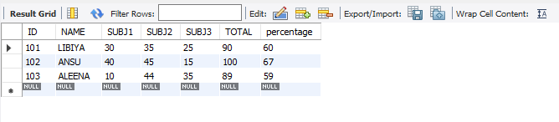

**STEP 5**

CREATE TABLE MARKS(MARKID INT PRIMARY KEY AUTO_INCREMENT,NAME VARCHAR(20),TOTAL_MARKS INT);

CREATE TRIGGER MARK_TRIGGER AFTER INSERT ON STUDENTINFO FOR EACH ROW INSERT INTO MARKS(NAME,TOTAL_MARKS) VALUES(new.NAME,new.TOTAL);

INSERT INTO STUDENTINFO(ID,NAME,SUBJ1,SUBJ2,SUBJ3) values(104,'MEEKHA',35,42,30),(105,'MEKHA',44,38,25);

SELECT *FROM MARKS;

**OUTPUT**

